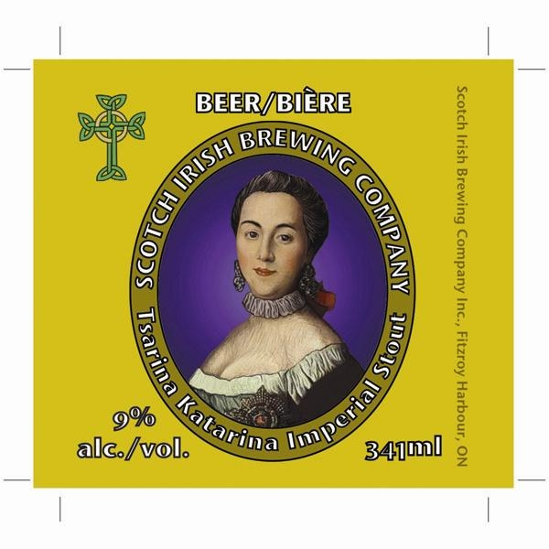

SCOTCH IRISH BREWING COMPANY
ORDER FORM
TSARINA KATARINA IMPERIAL STOUT

FIRST NAME: LAST NAME:
STREET ADDRESS:
CITY:
PROVINCE: Ontario (please note that our beer may only be sold in Ontario)
POSTAL CODE:
DAYTIME TEL: EVENING TEL:
CELL: FAX:
E-MAIL:
YES, I WOULD LIKE TO PURCHASE CASE(S) OF TSARINA KATARINA IMPERIAL STOUT @ $ 75.00 PER 24 –341ML BOTTLE CASE.
TOTAL ORDER VALUE: $ .00 PAYABLE BY CHEQUE.

PLEASE SEND CHEQUES TO:
SCOTCH IRISH BREWING COMPANY
113 SNYE CT., BOX 194

FITZROY HARBOUR ON K0A 1X0

IF YOU HAVE ANY QUESTIONS PLEASE CALL PERRY AT: 1-888-577-5088

